THE COMPLETE GUIDE TO
Data Visualization in Python
Matplotlib · Seaborn · Plotly · NumPy
Every Plot Type · Python Code · ML/DL/CV Use Cases · Edge Cases · Diagrams
For NAVTTC Data Science Program · 2026

Table of Contents
1. Matplotlib — The Foundation
2. Line Plot
3. Scatter Plot
4. Bar Plot
5. Histogram & KDE
6. Box Plot
7. Violin Plot
8. Distribution Plots (Seaborn)
9. Categorical Plots (Seaborn)
10. Matrix Plots / Heatmaps
11. Regression Plots
12. Pie Chart & Donut Chart
13. Area Chart
14. Hexbin Plot
15. ROC Curve & AUC
16. Feature Importance Plot
17. t-SNE / UMAP Visualization
18. Plotly — Interactive Plots
19. Working with Images (CV)
20. Axis, Titles & Professional Styling
21. Quick Reference — Choose the Right Plot

1. Matplotlib — The Foundation
Matplotlib is Python's most popular plotting library. It was created by John D. Hunter in 2003 and is now the backbone of almost every other visualization tool in Python (Seaborn, Pandas plotting, etc.).
Think of Matplotlib as a blank canvas. You decide every single thing: the colors, the sizes, the labels, the layout. This makes it incredibly flexible — but also verbose.

1.1 Two Ways to Plot

The Functional Way (plt.plot)
Quick and simple. Works like MATLAB. Great for one-off charts.
Functional / pyplot Style
import matplotlib.pyplot as plt
import numpy as np

x = np.linspace(0, 10, 100)
y = x**2

plt.plot(x, y)
plt.title("Hello World in Matplotlib")
plt.xlabel("X-Axis")
plt.ylabel("Y-Axis")
plt.show()

The Object-Oriented Way (fig, ax)
Professional way. Gives you full control. Use this in real projects and when making subplots.
Object-Oriented Style
fig, ax = plt.subplots(figsize=(10, 6)) # Create figure + axes

ax.plot(x, y, color='blue', linewidth=2, label='y = x²')
ax.set_title('OO Way Plot', fontsize=14, fontweight='bold')
ax.set_xlabel('X Variable')
ax.set_ylabel('Y Variable')
ax.legend()
plt.tight_layout()
plt.show()

1.2 Figure Anatomy
Every Matplotlib plot is made of several nested components. Understanding this helps you customize any part of a plot.
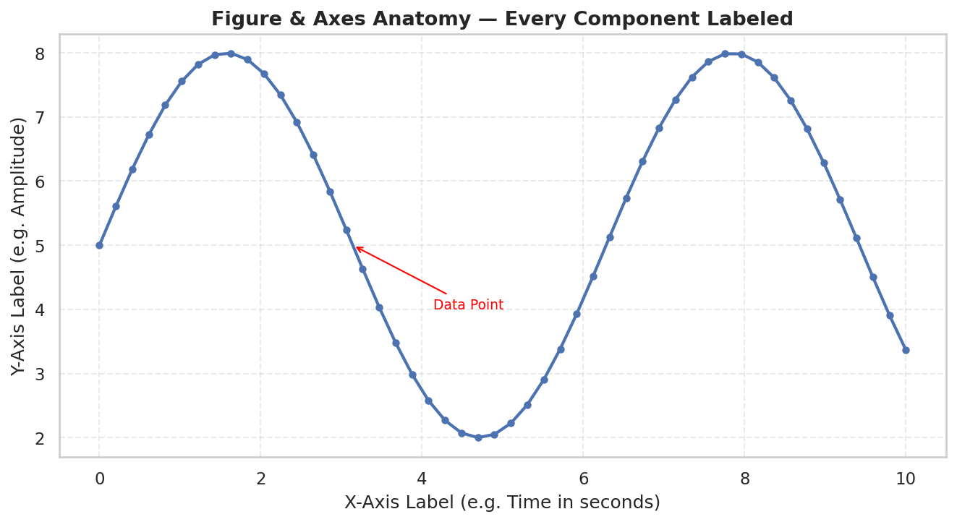
ℹ Figure = the entire window/image. Axes = the actual plot area inside it. You can have multiple Axes in one Figure.
Component | What It Is | How to Control
Figure | The whole canvas/image | plt.figure(figsize=(10,6))
Axes | The plot area (one chart) | fig, ax = plt.subplots()
X-Axis / Y-Axis | The measurement scales | ax.set_xlabel(), ax.set_ylabel()
Title | Chart headline | ax.set_title()
Spine | The border lines around axes | ax.spines['top'].set_visible(False)
Ticks | Marks on the axis | ax.tick_params()
Grid | Background reference lines | ax.grid(True, alpha=0.4)
Legend | Key for multiple series | ax.legend()

1.3 Subplots
Subplots let you put multiple charts side by side in one figure. You create a grid of axes using plt.subplots(rows, cols).
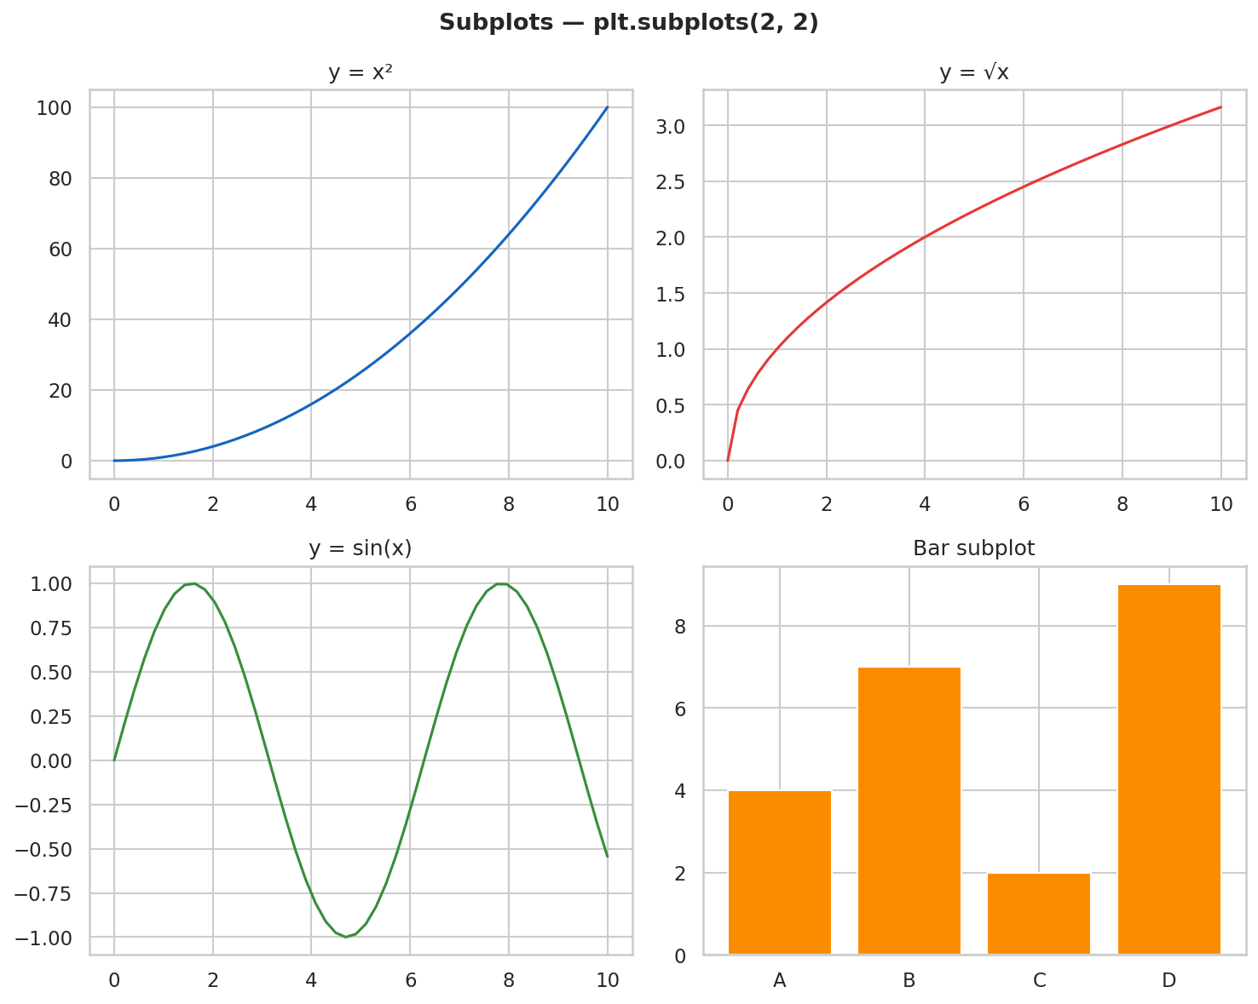
Creating a 2×2 Grid of Subplots
fig, axes = plt.subplots(2, 2, figsize=(12, 8)) # 2 rows, 2 cols
fig.suptitle('My Dashboard', fontsize=16) # overall title

axes[0, 0].plot(x, y); axes[0, 0].set_title('Top Left')
axes[0, 1].scatter(x, y); axes[0, 1].set_title('Top Right')
axes[1, 0].bar(cats, vals); axes[1, 0].set_title('Bottom Left')
axes[1, 1].hist(data); axes[1, 1].set_title('Bottom Right')

plt.tight_layout() # prevents overlap
plt.show()

1.4 Object-Oriented: fig.add_axes()
For more control, you can manually place axes anywhere on the figure using pixel-like fractions: [left, bottom, width, height] — all from 0 to 1.
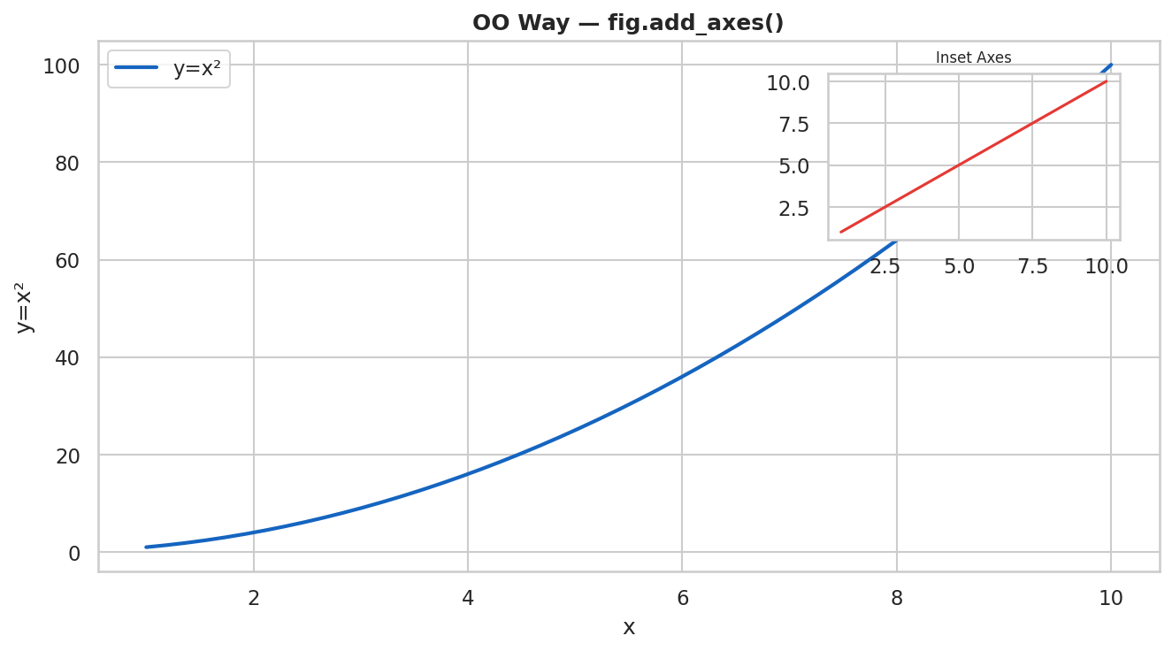
Manual Axis Placement (Inset Plots)
fig = plt.figure(figsize=(10, 6))

# Main plot: starts 10% from left, 10% from bottom, 80% wide, 80% tall
ax1 = fig.add_axes([0.1, 0.1, 0.8, 0.8])
ax1.plot(x, y, label='Main')

# Inset/small plot inside the big one
ax2 = fig.add_axes([0.65, 0.65, 0.22, 0.22])
ax2.plot(x, np.sqrt(y), color='red')
ax2.set_title('Inset', fontsize=8)

plt.show()

1.5 Styling Lines and Points
Line Styles, Colors, Markers
# Colors: named ('red'), hex ('#FF5722'), RGB ((0.2, 0.4, 0.8))
ax.plot(x, y, color='steelblue', linewidth=2.0, linestyle='-', label='Solid')
ax.plot(x, z, color='#E53935', linewidth=1.5, linestyle='--', label='Dashed')
ax.plot(x, a, color='green', linewidth=1.0, linestyle='-.', label='Dash-Dot')
ax.plot(x, b, color='purple', linewidth=0.8, linestyle=':', label='Dotted')

# Markers: 'o'=circle, 's'=square, '^'=triangle, 'D'=diamond, '+'=plus
ax.plot(x, y, marker='o', markersize=5, markerfacecolor='white')

# Combined shorthand: color + marker + line
ax.plot(x, y, 'b-o') # blue solid line with circle markers

⚠ EDGE CASE — Overlapping lines: If lines overlap, use alpha=0.6 to make them semi-transparent. Or offset them slightly.

1.6 Global Styling with rcParams
Set Consistent Style for All Plots
plt.rcParams.update({
'font.family': 'Arial',
'font.size': 11,
'axes.titlesize': 14,
'axes.titleweight': 'bold',
'axes.labelsize': 12,
'axes.grid': True,
'grid.alpha': 0.3,
'grid.linestyle': '--',
'axes.spines.top': False,
'axes.spines.right': False,
'figure.dpi': 150,
})
# Now every plot you make will use these defaults

2. Line Plot
A line plot connects data points with a continuous line. It is the go-to chart whenever you have ordered data — most commonly data that changes over time.
Think of it like a heart rate monitor: time on X, value on Y, and the line shows how the value evolves.
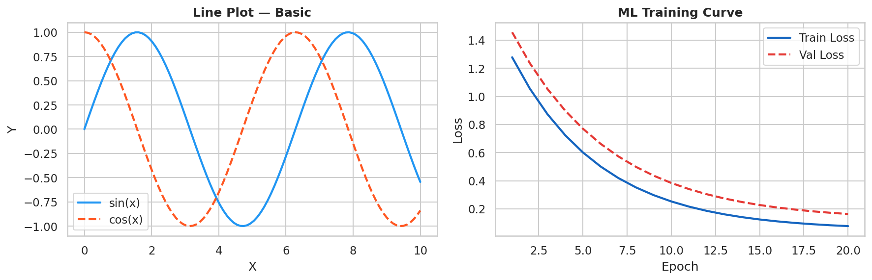

2.1 When to Use Line Plots
Use Case | Example
Time series data | Stock prices, temperature over weeks, website traffic by day
ML/DL training curves | Plot loss and accuracy per epoch to detect overfitting
Mathematical functions | Visualizing sin(x), polynomials, activation functions
Continuous trends | Population growth, economic indicators over years
Comparing multiple sequences | Multiple models' performance vs. time

2.2 Python Code
Basic Line Plot
import matplotlib.pyplot as plt
import numpy as np

x = np.linspace(0, 10, 100)
y = np.sin(x)

fig, ax = plt.subplots(figsize=(10, 5))
ax.plot(x, y, color='#2196F3', linewidth=2, label='sin(x)')
ax.set_title('Sine Wave', fontweight='bold')
ax.set_xlabel('X'); ax.set_ylabel('Y')
ax.legend()
plt.tight_layout()
plt.show()

ML Training Curve — Most Common DS Use Case
epochs = range(1, 51)
train_loss = [...] # your losses list
val_loss = [...]

fig, ax = plt.subplots(figsize=(10, 5))
ax.plot(epochs, train_loss, label='Train Loss', color='#1565C0', lw=2)
ax.plot(epochs, val_loss, label='Val Loss', color='#E53935', lw=2, ls='--')

# Vertical line to mark where overfitting starts
ax.axvline(x=30, color='orange', ls=':', lw=1.5, label='Overfit Start')

ax.set_xlabel('Epoch'); ax.set_ylabel('Loss')
ax.set_title('Training vs Validation Loss', fontweight='bold')
ax.legend()
plt.tight_layout(); plt.show()

2.3 Edge Cases & Pitfalls
Problem | Cause | Fix
Flat/no line visible | Data not sorted by X | Sort data first: df.sort_values('x')
Jagged zigzag line | X values out of order | Use np.sort(x) before plotting
Line disappears at edge | X range too narrow | Use ax.set_xlim(min, max)
Y-axis doesn't start at 0 | Auto-scaling | Use ax.set_ylim(0, max_val) for bar-like data
Too many lines = messy | Overplotting | Use alpha=0.4 or highlight top 3, gray rest
Missing data gaps | NaN values in series | Plot will break at NaN — forward-fill or mark gaps

2.4 DS / ML / DL Use Cases
✅ ML: Always plot both train and val loss together. A growing gap = overfitting. Both decreasing = healthy.
ML: Training/validation loss curves, learning rate schedules, accuracy per epoch
DL: Per-layer gradient norms over training (detect vanishing/exploding gradients)
CV: mAP (mean average precision) per epoch for object detection models
Data Science: Time-series analysis, sales trends, anomaly detection baselines

3. Scatter Plot
A scatter plot places individual data points as dots on a 2D coordinate system. Each point has an X value and a Y value. It is used to show the relationship (correlation) between two numeric variables.
Imagine two exam scores for 100 students: plot math score on X and science score on Y. If students who score high in math also score high in science, the dots form a diagonal line — that's positive correlation.
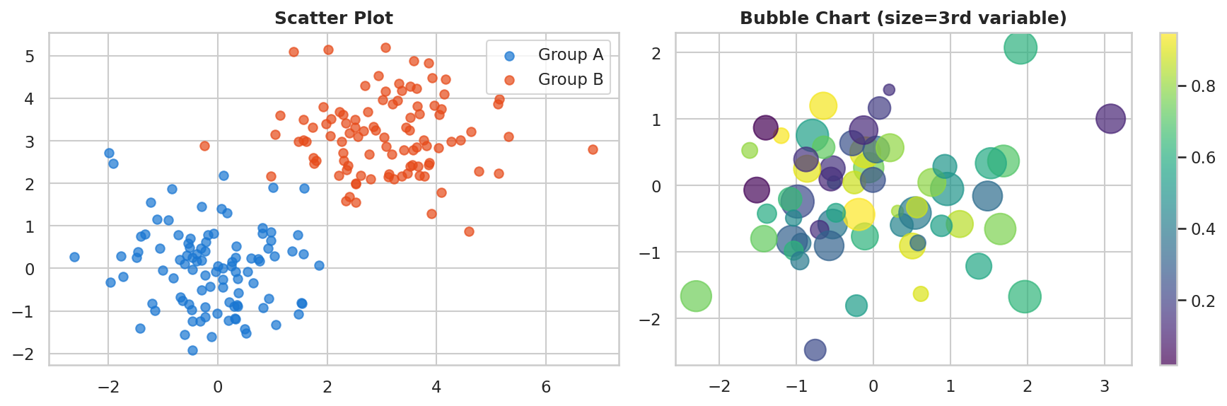

3.1 When to Use Scatter Plots
Use Case | Example
Correlation analysis | Does income correlate with education level?
Outlier detection | Spot data points far from the cluster
Cluster visualization | Show groups after K-Means or DBSCAN
Feature relationships | height vs weight, bill vs tip
t-SNE / UMAP projections | Visualize 512-dim embeddings in 2D

3.2 Python Code
Basic Scatter Plot
import matplotlib.pyplot as plt
import numpy as np

np.random.seed(42)
x = np.random.randn(200)
y = x * 1.5 + np.random.randn(200) * 0.5 # correlated with x

fig, ax = plt.subplots(figsize=(8, 6))
ax.scatter(x, y, alpha=0.6, color='#1976D2', edgecolors='white', linewidths=0.5)
ax.set_xlabel('Feature X'); ax.set_ylabel('Feature Y')
ax.set_title('Scatter Plot — Positive Correlation', fontweight='bold')
plt.tight_layout(); plt.show()

Multi-Class Scatter (for ML clustering)
# Different colors per class
classes = [0, 0, 1, 1, 2, 2, ...] # labels
colors = ['#1976D2', '#E53935', '#388E3C']

for cls in range(3):
mask = (np.array(classes) == cls)
ax.scatter(x[mask], y[mask], label=f'Class {cls}',
alpha=0.7, s=50, color=colors[cls])
ax.legend(title='Class')

Bubble Chart — 3rd Variable as Size
# Size of dots encodes a 3rd variable
sizes = df['population'] / 1000 # scale to reasonable range
scatter = ax.scatter(df['gdp'], df['happiness'],
s=sizes, # size = population
c=df['continent_code'], # color = region
cmap='tab10', alpha=0.7)
plt.colorbar(scatter, label='Region')

3.3 Edge Cases & Pitfalls
Problem | Cause | Fix
All dots overlap (overplotting) | Too many points in same area | Use alpha=0.1, or hexbin, or jitter
Dots too small to see | Default size too small | Increase s=50 or s=100
Misleading bubble sizes | Encoding value directly as radius | Area should encode value: s = value * scale
Correlation looks wrong | Different scales on axes | Use ax.set_aspect('equal') or standardize data
Too many classes | > 8 different colors | Limit to top classes + "Other" group

3.4 DS / ML / DL / CV Use Cases
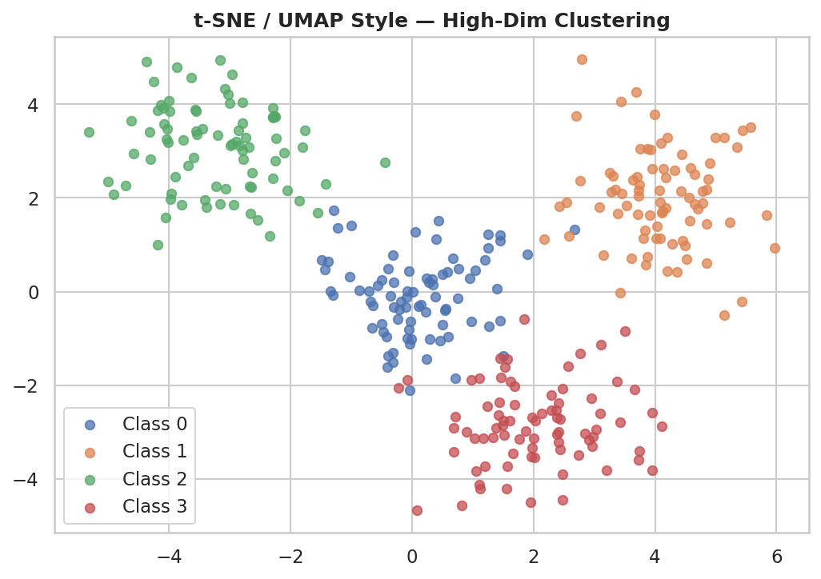
t-SNE / UMAP: After reducing high-dimensional data (e.g., 768-dim BERT embeddings) to 2D, scatter plots reveal natural clusters and class separability.
CV: Visualize image embeddings — each dot = one image. Dots of same class should cluster together (measures representation quality).
ML: Predicted vs Actual scatter — perfect model = diagonal line. Deviations reveal systematic errors.
✅ TIP: For datasets > 5000 points, switch to hexbin plot — it solves the overplotting problem and shows density much better.

4. Bar Plot
Bar plots use rectangular bars to compare values across categories. The height (or length) of each bar is proportional to the value it represents. It is one of the most universally understood chart types.
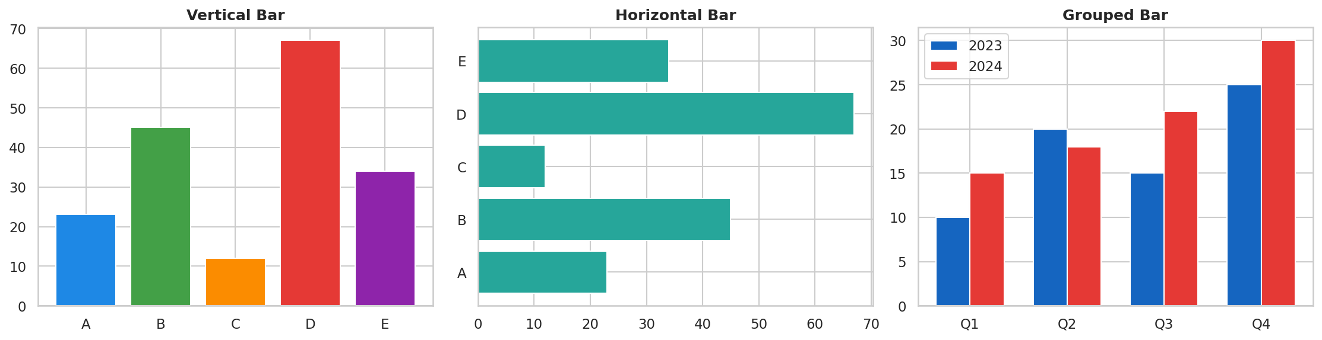

4.1 Types of Bar Plots
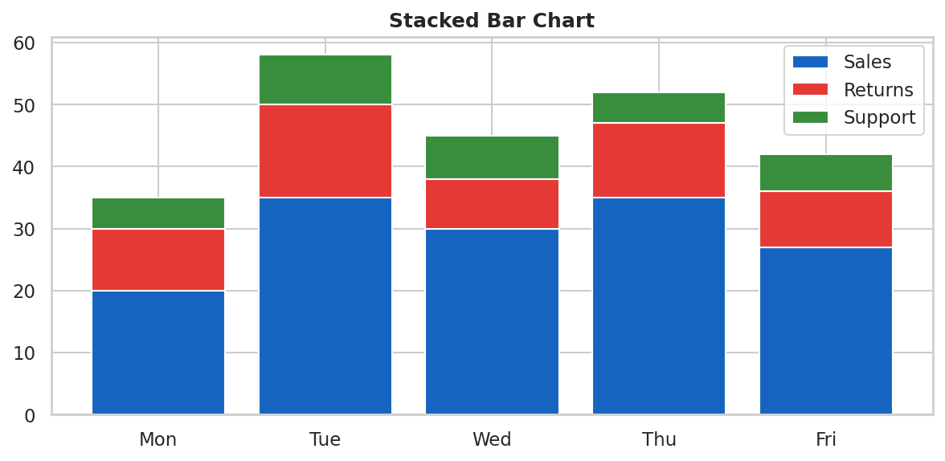
Type | When to Use | Code
Vertical Bar | Short category names, ≤ 10 categories | ax.bar(x, y)
Horizontal Bar | Long category names, many categories | ax.barh(x, y)
Grouped Bar | Compare sub-groups within each category | ax.bar(x-w/2, y1, w); ax.bar(x+w/2, y2, w)
Stacked Bar | Show part-to-whole across categories | ax.bar(x, y1); ax.bar(x, y2, bottom=y1)
100% Stacked Bar | Compare proportions (not absolute values) | Normalize each group to 100% first
Seaborn barplot | Auto-computes mean + confidence interval | sns.barplot(x=..., y=..., data=...)

4.2 Python Code
Vertical and Horizontal Bar
import matplotlib.pyplot as plt
import seaborn as sns

# Vertical bar
fig, ax = plt.subplots(figsize=(8, 5))
ax.bar(['A','B','C','D'], [23, 45, 12, 67],
color=['#1E88E5','#43A047','#FB8C00','#E53935'],
edgecolor='white', linewidth=0.8)
ax.set_title('Category Comparison', fontweight='bold')
ax.set_ylabel('Value')

# Add value labels on top of bars
for bar in ax.patches:
ax.text(bar.get_x() + bar.get_width()/2, bar.get_height() + 0.5,
f'{bar.get_height():.0f}', ha='center', va='bottom', fontsize=10)

Grouped Bar Chart
import numpy as np

categories = ['Q1', 'Q2', 'Q3', 'Q4']
vals_2023 = [10, 20, 15, 25]
vals_2024 = [15, 18, 22, 30]
x = np.arange(len(categories)); w = 0.35

fig, ax = plt.subplots(figsize=(9, 5))
bars1 = ax.bar(x - w/2, vals_2023, w, label='2023', color='#1565C0')
bars2 = ax.bar(x + w/2, vals_2024, w, label='2024', color='#E53935')
ax.set_xticks(x); ax.set_xticklabels(categories)
ax.legend(); ax.set_title('Revenue by Quarter', fontweight='bold')

Seaborn barplot — Auto Mean + Confidence Interval
import seaborn as sns
tips = sns.load_dataset('tips')

# Automatically shows mean + 95% CI error bars
sns.barplot(x='day', y='total_bill', data=tips,
palette='Set2', estimator='mean', errorbar='ci')

4.3 Edge Cases & Pitfalls
Problem | Cause | Fix
Y-axis NOT starting at 0 | Auto-scale or truncated axis | ALWAYS start bars at 0. Use ax.set_ylim(0, max)
Hard to compare in stacked | Middle segments float | Use grouped bar for precise comparison
3D bar chart | 3D looks impressive but distorts perception | Never use 3D bars — use flat 2D always
Too many categories | > 15 bars = cluttered | Keep top-N, group rest as "Other"
Categories are numeric | Bar chart treats them as categories | If numeric+ordered, use line chart instead
Missing category | Category with 0 value not shown | Explicitly include zero-value bars
⚠ GOLDEN RULE: Bar charts must ALWAYS start at zero. Starting at a higher value is a visual lie that exaggerates differences.

4.4 DS / ML Use Cases
Feature Importance: Horizontal bar chart sorted by importance score — immediately shows which features matter most for your model.
Class Distribution: Show how many samples per class in your dataset. Reveals class imbalance before training.
Model Comparison: Bar chart of accuracy/F1/AUC for multiple models side by side.
Ablation Studies: Show performance with vs without each component of your model.
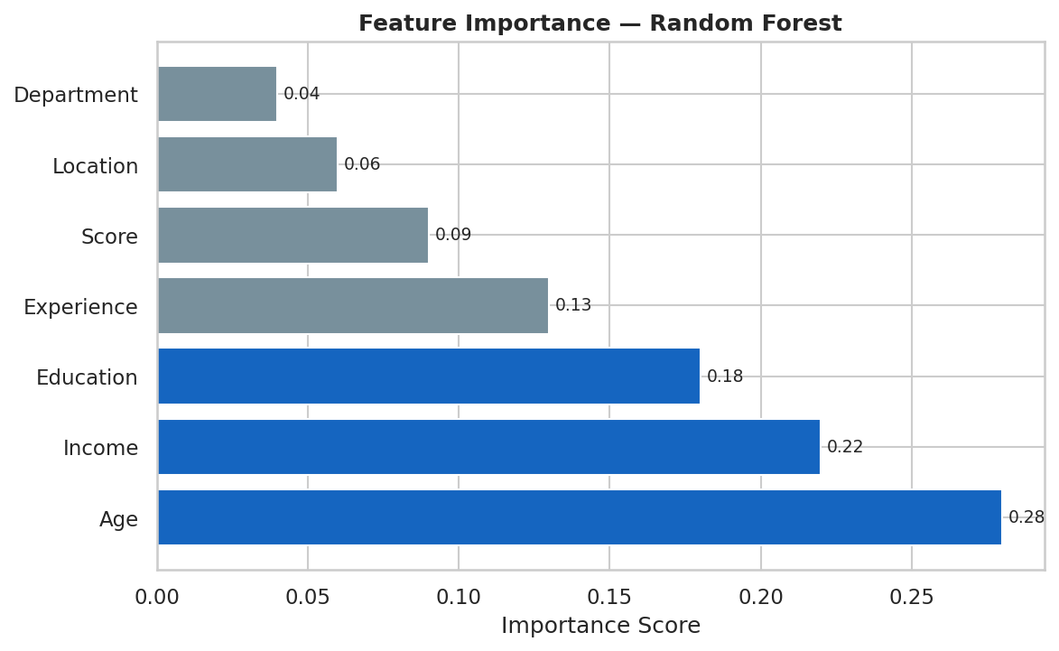

5. Histogram & KDE
A histogram groups numeric data into "bins" (ranges) and shows how many data points fall into each bin. It reveals the shape, spread, and center of a distribution. Think of it like sorting exam scores into buckets: 0-10, 10-20, 20-30... and counting how many students fall in each.
A KDE (Kernel Density Estimate) is a smooth version of a histogram — instead of discrete bars, it gives you a smooth curve showing where the data is concentrated.
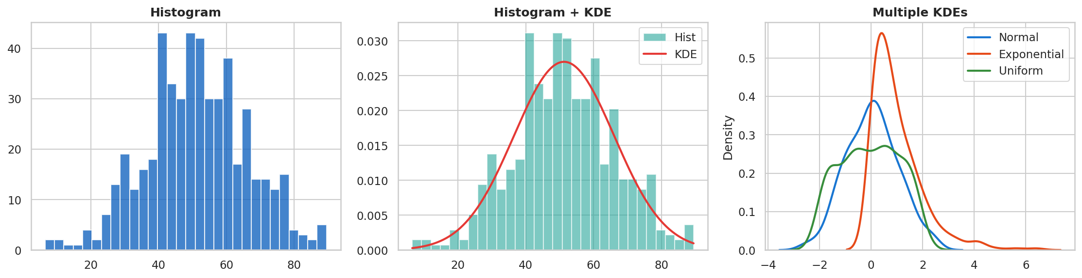

5.1 When to Use Histograms
Use Case | Example
Distribution shape | Is data normal, skewed, bimodal?
Outlier detection | Long tail on right = some extreme values
Feature analysis in ML | Check each feature's distribution before modeling
Comparing distributions | Show overlapping histograms for two groups
Residual analysis | Histogram of residuals should be bell-shaped

5.2 Python Code
Histogram with Seaborn
import seaborn as sns
import matplotlib.pyplot as plt

tips = sns.load_dataset('tips')

# histplot = modern replacement for distplot
fig, ax = plt.subplots(figsize=(8, 5))
sns.histplot(tips['total_bill'],
bins=25, # number of bins
kde=True, # overlay smooth KDE curve
color='#1976D2',
ax=ax)
ax.set_title('Distribution of Total Bill', fontweight='bold')
plt.tight_layout(); plt.show()

Multiple Distributions — Overlapping
fig, ax = plt.subplots(figsize=(9, 5))
for group, color in [('Lunch', '#1976D2'), ('Dinner', '#E53935')]:
subset = tips[tips['time'] == group]['total_bill']
sns.histplot(subset, kde=True, color=color, alpha=0.5,
label=group, ax=ax)
ax.legend(title='Meal Time')
ax.set_title('Bill Distribution: Lunch vs Dinner', fontweight='bold')

Choosing the Right Number of Bins
# Too few bins = too much smoothing (hides structure)
# Too many bins = noisy (shows random fluctuation)

# Rules of thumb:
# Sturges' Rule: bins = ceil(log2(n) + 1)
# Scott's Rule: bins = 'auto' (matplotlib default)
# Rice Rule: bins = ceil(2 * n**(1/3))

# In matplotlib:
ax.hist(data, bins='auto') # automatic
ax.hist(data, bins=30) # fixed number
ax.hist(data, bins=np.arange(0, 100, 5)) # custom bin edges

5.3 KDE in Detail
KDE places a small "kernel" (like a mini bell curve) at each data point, then adds them all up to get a smooth density curve. The bandwidth parameter controls how smooth the curve is — small bandwidth = spiky (overfits), large bandwidth = very smooth (underfits).
KDE with Custom Bandwidth
# Using scipy directly for more control
from scipy.stats import gaussian_kde
import numpy as np

data = np.random.normal(0, 1, 500)
kde = gaussian_kde(data, bw_method=0.3) # 0.3 = narrow bandwidth
x_range = np.linspace(-4, 4, 200)
ax.plot(x_range, kde(x_range), lw=2, label='KDE bw=0.3')

# Using seaborn with bw_adjust
sns.kdeplot(data, bw_adjust=0.5, label='narrow') # spiky
sns.kdeplot(data, bw_adjust=2.0, label='smooth') # smooth

5.4 Edge Cases & Pitfalls
Problem | Fix
Wrong bin count changes the shape story | Always try 3-4 bin counts and pick the most informative one
KDE extends below zero for positive-only data | Use clip=(0, None) in sns.kdeplot to cut off at 0
Comparing groups with different n | Use density=True (normalize to area=1)
Bimodal shape = two hidden groups | Investigate if there's a categorical variable causing the split
Outliers squish the main distribution | Remove or clip extreme outliers, or use log scale

5.5 DS / ML / DL Use Cases
Before modeling: Check if features are normally distributed (some models assume this). Apply log-transform to right-skewed data.
After modeling: Plot histogram of residuals — should be bell-shaped. If skewed, your model is systematically wrong in one direction.
DL: Plot gradient distributions per layer to check for vanishing (all near zero) or exploding (huge values) gradients.
✅ PRO TIP: In data preprocessing pipelines, always plot histograms for every numeric feature. This single step reveals outliers, skewness, and distributions in one glance.

6. Box Plot
A box plot (also called a box-and-whisker plot) compresses an entire distribution into a simple diagram showing 5 key statistics at once. It's like a summary statistics report turned into a visual.
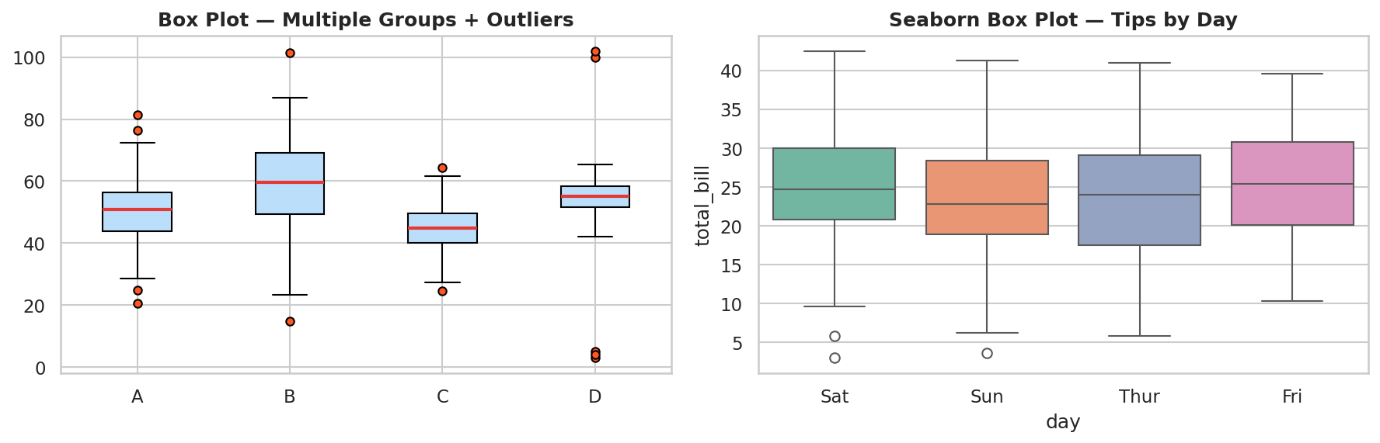

6.1 Anatomy of a Box Plot
Component | Statistical Meaning | How to Read It
Bottom of box (Q1) | 25th percentile | 25% of data falls below this line
Middle line (Q2) | Median (50th percentile) | Half the data is above, half below
Top of box (Q3) | 75th percentile | 75% of data falls below this line
Box height (IQR) | Interquartile Range = Q3 - Q1 | Tall box = data is spread out
Lower whisker | Q1 - 1.5×IQR | Smallest non-outlier value
Upper whisker | Q3 + 1.5×IQR | Largest non-outlier value
Dots beyond whiskers | Outliers | Values that are unusually extreme

6.2 Python Code
Matplotlib Box Plot
import matplotlib.pyplot as plt
import numpy as np

np.random.seed(42)
data_a = np.random.normal(50, 10, 100)
data_b = np.random.normal(65, 8, 100)
data_c = np.concatenate([np.random.normal(55, 5, 95), [100, 102, 5, 3]]) # with outliers

fig, ax = plt.subplots(figsize=(8, 6))
bp = ax.boxplot([data_a, data_b, data_c],
labels=['Group A', 'Group B', 'Group C (outliers)'],
patch_artist=True,
boxprops=dict(facecolor='#BBDEFB', color='#1565C0'),
medianprops=dict(color='#E53935', linewidth=2.5),
flierprops=dict(marker='o', markerfacecolor='#FF5722', markersize=5))
ax.set_title('Box Plot Comparison', fontweight='bold')
plt.tight_layout(); plt.show()

Seaborn Box Plot — Grouped by Category
import seaborn as sns
tips = sns.load_dataset('tips')

fig, ax = plt.subplots(figsize=(10, 6))
sns.boxplot(x='day', y='total_bill', data=tips,
hue='sex', # split each day by gender
palette='Set2',
ax=ax)
ax.set_title('Bill Distribution by Day and Gender', fontweight='bold')
plt.tight_layout(); plt.show()

6.3 Edge Cases & Pitfalls
Problem | Fix
Median not centered = skewed distribution | Expected behavior — it means data is not symmetric
Many outliers in one group | Investigate those outliers — they might be data errors
All boxes look flat/thin | Data range very small compared to axis scale — zoom in
Groups have very different n | Box plot hides this — add jitter or note sample sizes
Notched box plot confusing | Notches show 95% CI of median — useful for comparing medians

6.4 DS / ML Use Cases
Outlier detection: Before ML preprocessing, box plots quickly show which features have extreme values that might need clipping or normalization.
Model comparison: Show distribution of cross-validation scores across folds — a tight box = stable model.
Comparing features: Compare the distribution of a feature across target classes. If a feature's distribution differs significantly between classes, it's a strong predictor.
ℹ Box plot vs Violin plot: Box plot shows less detail but is more compact. Violin plot shows full distribution shape. Use violin when you suspect bimodal distributions.

7. Violin Plot
A violin plot is like a box plot, but instead of just showing quartiles, it shows the full probability density on both sides. The wider the "belly" of the violin, the more data points exist in that region.
Imagine mirroring a KDE curve on both sides of a vertical axis — that's a violin plot. It reveals shapes that box plots hide, like bimodal distributions (two humps).
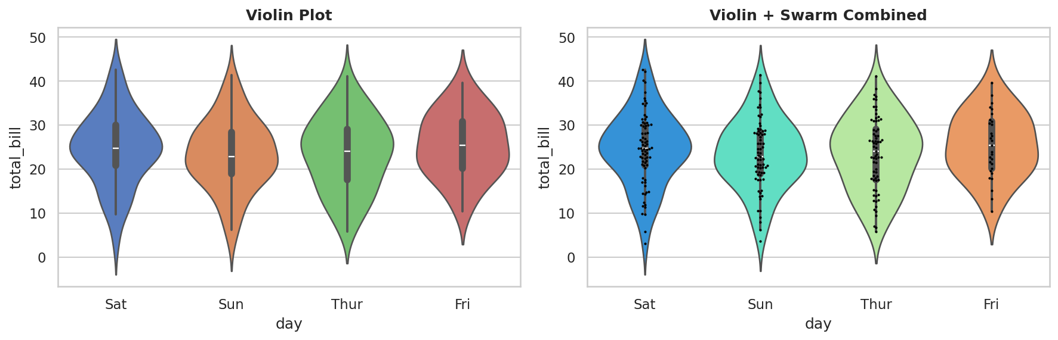

7.1 When to Use Violin vs Box Plot
Situation | Use Box Plot | Use Violin Plot
Distribution shape matters | ✗ (hides shape) | ✓ (shows full shape)
Bimodal distributions | ✗ (hides two humps) | ✓ (clearly shows humps)
Space is limited | ✓ (compact) | ✗ (takes more space)
Comparing many groups | ✓ (up to 10+ groups) | ✗ (gets crowded > 6)
Showing individual points | ✗ (not standard) | ✓ (combine with swarm)
Non-technical audience | ✓ (familiar) | ✗ (less familiar)

7.2 Python Code
Violin Plot with Seaborn
import seaborn as sns
tips = sns.load_dataset('tips')

fig, ax = plt.subplots(figsize=(9, 6))
sns.violinplot(x='day', y='total_bill', data=tips,
palette='muted',
inner='box', # 'box', 'quart', 'point', 'stick', None
cut=2, # extend how far past data range
ax=ax)
ax.set_title('Violin Plot — Bill by Day', fontweight='bold')
plt.tight_layout(); plt.show()

Violin + Swarm (Best of Both Worlds)
# Violin shows distribution shape
# Swarm shows all individual data points
fig, ax = plt.subplots(figsize=(10, 6))

sns.violinplot(x='day', y='total_bill', data=tips,
palette='rainbow', inner=None, ax=ax)
sns.swarmplot(x='day', y='total_bill', data=tips,
color='black', size=2.5, alpha=0.7, ax=ax)

ax.set_title('Violin + Swarm — Complete View', fontweight='bold')
plt.tight_layout(); plt.show()

7.3 DS / ML Use Cases
Cross-validation results: Show the distribution of accuracy across folds for each model. A narrow violin = stable, consistent model.
Hyperparameter tuning: Show metric distribution for each hyperparameter setting.
Class-conditional distributions: For each class, show the distribution of a feature. Wide separation between class violins = discriminative feature.

8. Distribution Plots (Seaborn)
Seaborn provides specialized distribution plots: displot, jointplot, pairplot, rugplot, and ECDF. These are higher-level than raw histograms and automatically combine multiple views.
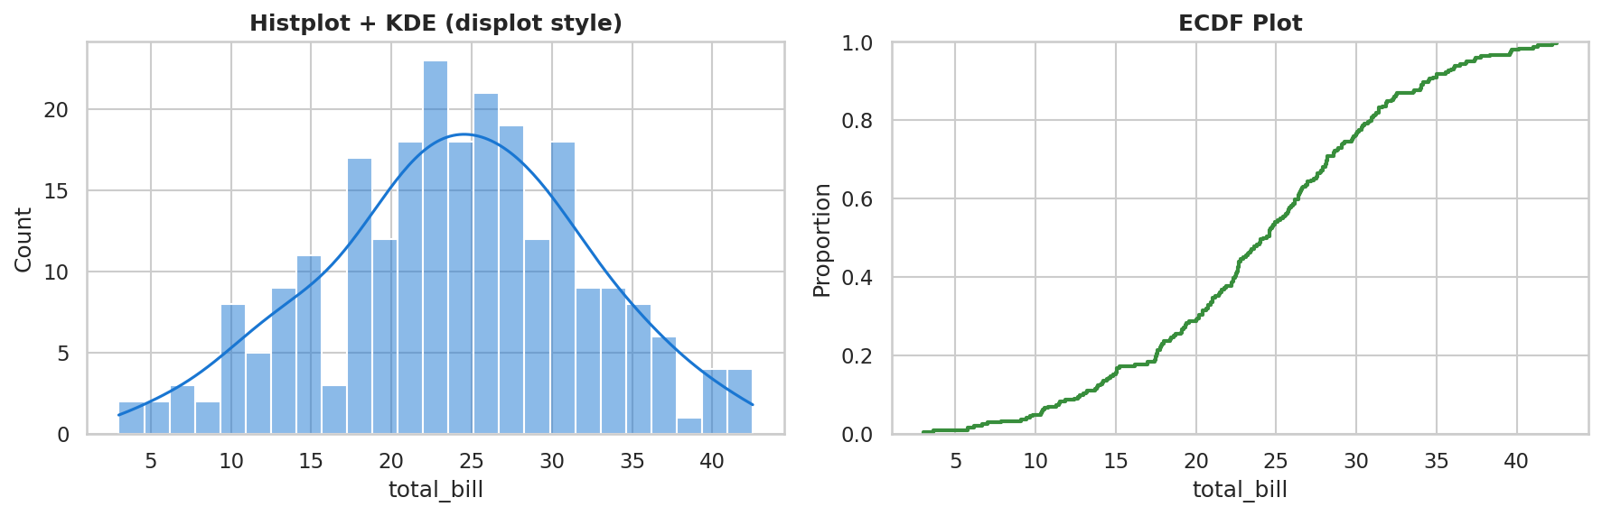

8.1 displot / histplot
sns.displot() is the modern one-stop-shop for univariate distributions. It can show histograms, KDE, ECDF, and rug marks.
displot and histplot
import seaborn as sns
tips = sns.load_dataset('tips')

# Figure-level function (creates its own figure)
sns.displot(tips['total_bill'], bins=25, kde=True)

# Axes-level function (works within plt.subplots)
fig, axes = plt.subplots(1, 2, figsize=(12, 4))
sns.histplot(tips['total_bill'], bins=20, kde=True, ax=axes[0])
sns.histplot(tips['tip'], bins=20, kde=True, ax=axes[1])
plt.tight_layout(); plt.show()

# Multiple distributions on one plot
sns.displot(tips, x='total_bill', hue='time', kind='kde', fill=True)

8.2 Joint Plot
A joint plot shows the relationship between two variables (like a scatter plot) AND their individual distributions on the margins simultaneously. This is incredibly useful for exploratory data analysis.
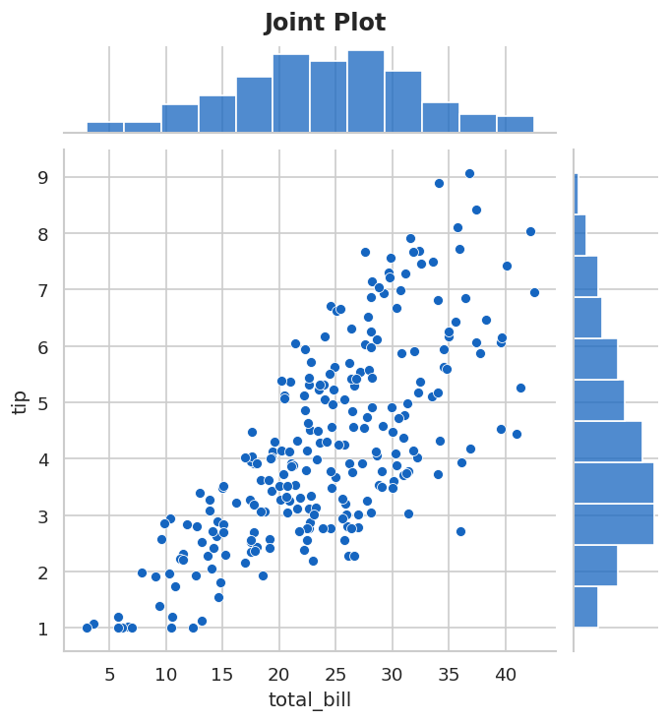
Joint Plot — All Kinds
# Scatter + marginal histograms
sns.jointplot(x='total_bill', y='tip', data=tips, kind='scatter')

# KDE contour + marginal KDE
sns.jointplot(x='total_bill', y='tip', data=tips, kind='kde', fill=True)

# Hexbin + marginals (for large datasets)
sns.jointplot(x='total_bill', y='tip', data=tips, kind='hex')

# Regression line + marginals
sns.jointplot(x='total_bill', y='tip', data=tips, kind='reg')

# Residuals from regression fit
sns.jointplot(x='total_bill', y='tip', data=tips, kind='resid')

8.3 Pair Plot
A pair plot creates a grid of plots where every numeric variable is plotted against every other variable. The diagonal shows each variable's own distribution. This gives you a quick overview of all pairwise relationships in your dataset in one shot.
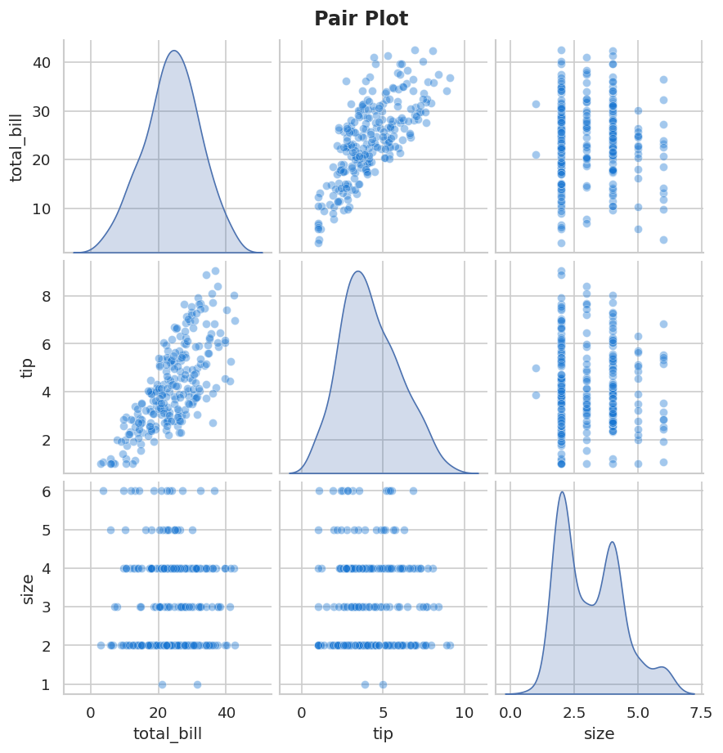
Pair Plot
import seaborn as sns
tips = sns.load_dataset('tips')

# Basic pair plot
sns.pairplot(tips)

# With hue (color by category)
sns.pairplot(tips, hue='sex', palette='Set1')

# Select specific columns (don't include all if dataset is large!)
sns.pairplot(tips[['total_bill', 'tip', 'size']],
diag_kind='kde', # distribution on diagonal
plot_kws={'alpha': 0.5})

⚠ Pair plot is heavy — for large datasets (> 50,000 rows), sample first: df.sample(5000) to keep it fast.

8.4 Rug Plot
A rug plot adds small tick marks along the axis showing the exact position of every data point. It is usually combined with a histogram or KDE to show where individual points actually are.
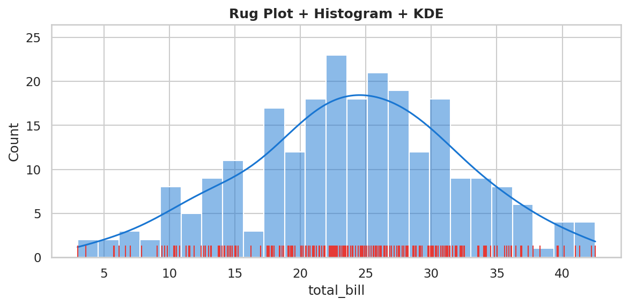
Rug Plot
fig, ax = plt.subplots(figsize=(8, 4))
sns.histplot(tips['total_bill'], bins=25, kde=True, ax=ax, alpha=0.5)
sns.rugplot(tips['total_bill'], ax=ax, height=0.05, color='red')

8.5 ECDF Plot
ECDF (Empirical Cumulative Distribution Function) plots the cumulative proportion of data up to each value. Unlike a histogram, it doesn't depend on bin width choices. The Y value at any X tells you: "What fraction of data is ≤ X?"
ECDF Plot
sns.ecdfplot(tips['total_bill'], color='#388E3C', linewidth=2)
ax.set_xlabel('Total Bill')
ax.set_ylabel('Cumulative Proportion')
# e.g. At x=20: y=0.5 means 50% of bills are ≤ $20

8.6 DS / ML Use Cases
EDA Phase: Pairplot is the single most powerful tool for initial data exploration — run it on every new dataset.
Feature selection: High correlation in pairplot → one feature is redundant → remove to reduce multicollinearity.
Data quality: ECDF quickly shows percentiles — "what value separates the top 10% of customers?"

9. Categorical Plots (Seaborn)
Categorical plots are specifically designed to visualize relationships between a categorical variable (like day of week, product type, country) and a numeric variable. Seaborn provides a rich set of categorical visualizations.
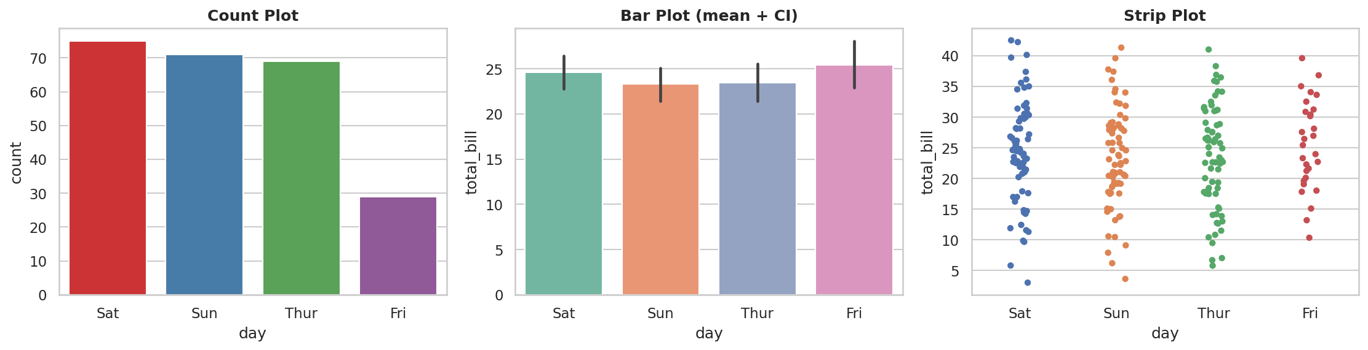

9.1 Count Plot
Count plot simply counts how many times each category appears in the data. It is a bar chart of frequencies, not values.
Count Plot
import seaborn as sns
tips = sns.load_dataset('tips')

# Count of each day
sns.countplot(x='day', data=tips, palette='Set1')

# With hue (split by smoker)
sns.countplot(x='day', data=tips, hue='smoker', palette='rainbow')

# Sort by frequency
order = tips['day'].value_counts().index
sns.countplot(x='day', data=tips, order=order, palette='viridis')

9.2 Bar Plot (Seaborn)
Seaborn's barplot shows the mean of a numeric variable for each category, with 95% confidence interval error bars automatically added. It is more statistically informative than matplotlib's plain bar chart.
Seaborn Bar Plot with Confidence Interval
# Shows mean total_bill per day, with CI bars
sns.barplot(x='day', y='total_bill', data=tips, palette='Set2')

# Change estimator function
import numpy as np
sns.barplot(x='sex', y='total_bill', data=tips,
estimator=np.sum, # show total, not mean
palette='Set1')

# With hue
sns.barplot(x='day', y='tip', data=tips,
hue='sex', palette='husl')

9.3 Strip Plot
A strip plot shows all individual data points as dots, arranged by category. Adding jitter spreads overlapping points horizontally so you can see them all.
Strip Plot
sns.stripplot(x='day', y='total_bill', data=tips,
jitter=True, # spread overlapping points
alpha=0.6,
palette='deep')

9.4 Swarm Plot
A swarm plot is like a strip plot but smarter — it positions dots so that no two dots overlap. This gives you a clear view of every single data point AND the distribution shape. Great for small to medium datasets.
Swarm Plot (and combining with Violin)
# Pure swarm
sns.swarmplot(x='day', y='total_bill', data=tips, palette='PiYG')

# Combined: violin (distribution) + swarm (individual points)
sns.violinplot(x='day', y='total_bill', data=tips,
palette='rainbow', inner=None)
sns.swarmplot(x='day', y='total_bill', data=tips,
color='black', size=2.5)

9.5 Point Plot
A point plot shows the mean value per category as a dot, connected by a line, with confidence interval bars. It is the best choice for showing interaction effects between two categorical variables.
Point Plot
sns.pointplot(x='day', y='total_bill', data=tips,
hue='sex', # show separate lines per gender
palette='Set1',
markers=['o', 's'], # different markers per group
linestyles=['-', '--'])

9.6 DS / ML Use Cases
Plot | ML / DS Application
Count Plot | Check class imbalance in classification datasets
Bar Plot | Compare model accuracy across different architectures
Strip / Swarm | Show per-sample metric values across categories
Point Plot | Interaction effects in A/B testing; show metric vs hyperparameter setting
Box + Cat | Feature value distribution per class (is this feature discriminative?)

10. Matrix Plots (Heatmaps)
Matrix plots visualize 2D data (a grid of values) using color intensity. The brighter or darker a cell, the higher or lower its value. Heatmaps are incredibly powerful for showing correlation matrices, confusion matrices, pivot tables, and any grid-structured data.
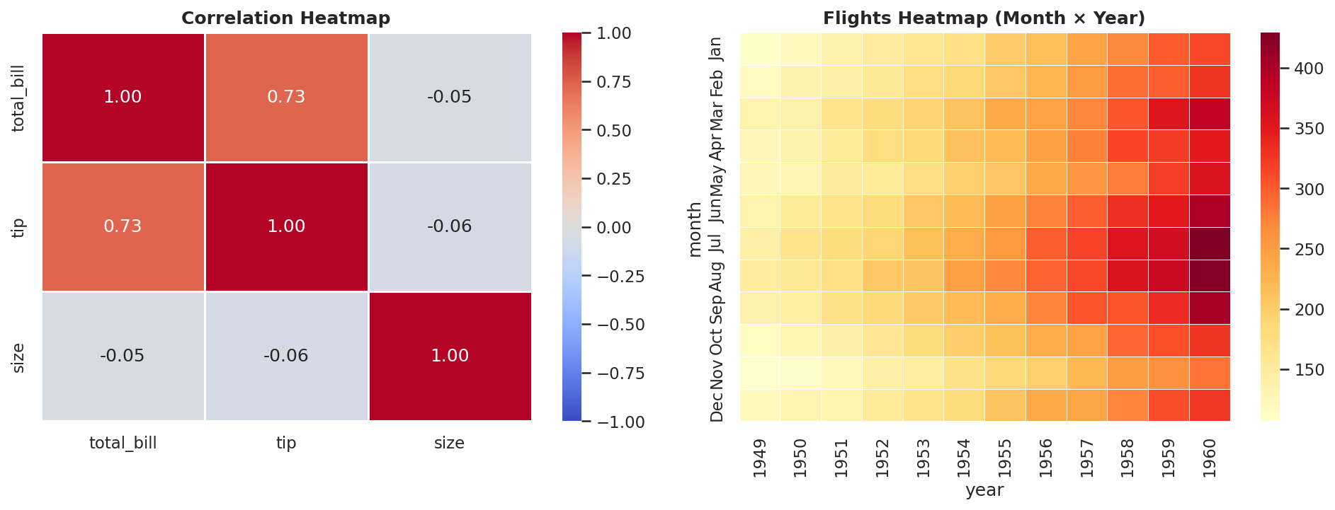

10.1 Correlation Heatmap
The most common use: visualize a correlation matrix. Each cell shows the correlation (−1 to 1) between two variables. Red = high positive correlation, Blue = negative correlation.
Correlation Heatmap
import seaborn as sns
tips = sns.load_dataset('tips')

# Calculate correlation matrix
corr = tips[['total_bill', 'tip', 'size']].corr()

fig, ax = plt.subplots(figsize=(7, 5))
sns.heatmap(corr,
annot=True, # show numbers in each cell
fmt='.2f', # 2 decimal places
cmap='coolwarm', # diverging colormap (good for correlation)
vmin=-1, vmax=1, # fix color range to [-1, 1]
linewidths=0.5, # cell borders
square=True, # make cells square
ax=ax)
ax.set_title('Correlation Matrix', fontweight='bold')
plt.tight_layout(); plt.show()

10.2 Flights Pivot Heatmap
Heatmap from Pivot Table
flights = sns.load_dataset('flights')

# Reshape: rows=month, columns=year, values=passengers
pvt = flights.pivot_table(values='passengers',
index='month',
columns='year')

sns.heatmap(pvt,
cmap='YlOrRd', # sequential colormap (for counts)
annot=True,
fmt='d',
linewidths=0.3)

10.3 Cluster Map
A cluster map is a heatmap with hierarchical clustering applied to both rows and columns, so that similar rows/columns are placed next to each other.
Cluster Map
sns.clustermap(corr_matrix,
cmap='coolwarm', annot=True,
figsize=(10, 8),
row_cluster=True, # cluster rows
col_cluster=True) # cluster columns

10.4 Confusion Matrix Heatmap
A confusion matrix heatmap is the standard way to evaluate classification models. Each row = actual class, each column = predicted class. The diagonal = correct predictions.
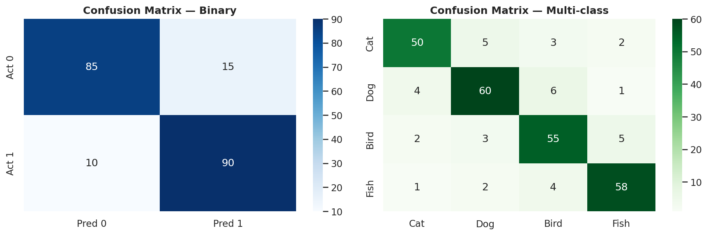
Confusion Matrix — ML Model Evaluation
from sklearn.metrics import confusion_matrix
import seaborn as sns

y_true = [0, 1, 0, 1, 1, 0, 1, 0]
y_pred = [0, 1, 1, 1, 0, 0, 1, 0]

cm = confusion_matrix(y_true, y_pred)

sns.heatmap(cm, annot=True, fmt='d', cmap='Blues',
xticklabels=['Pred 0', 'Pred 1'],
yticklabels=['Act 0', 'Act 1'])
plt.title('Confusion Matrix', fontweight='bold')
plt.ylabel('Actual'); plt.xlabel('Predicted')

10.5 Edge Cases & Pitfalls
Problem | Fix
Color scale misleading | For correlation, always set vmin=-1, vmax=1
Too many features = cluttered heatmap | Use cluster map to group similar features; or show only top correlated pairs
Sequential vs diverging colormap confusion | Use coolwarm/RdBu for diverging data (correlation); YlOrRd/Blues for counts
Annotations too small | Reduce number of features or increase figure size
Duplicate correlation (symmetric matrix) | Use mask=np.triu(np.ones_like(corr)) to show only lower triangle

10.6 DS / ML / DL / CV Use Cases
Feature selection: High correlation (> 0.9) between two features means one is redundant — drop it to reduce multicollinearity.
Model evaluation: Confusion matrix is the single most important visualization for classification models — it shows exactly where the model makes errors.
CV (Computer Vision): Attention maps in Transformers are visualized as heatmaps — shows which input tokens the model focused on.
DL: Weight matrices and activation patterns across layers visualized as heatmaps.

11. Regression Plots
Regression plots show the relationship between two numeric variables AND overlay a regression line (the best-fit line) to show the trend. They immediately show how strongly correlated two variables are and in what direction.
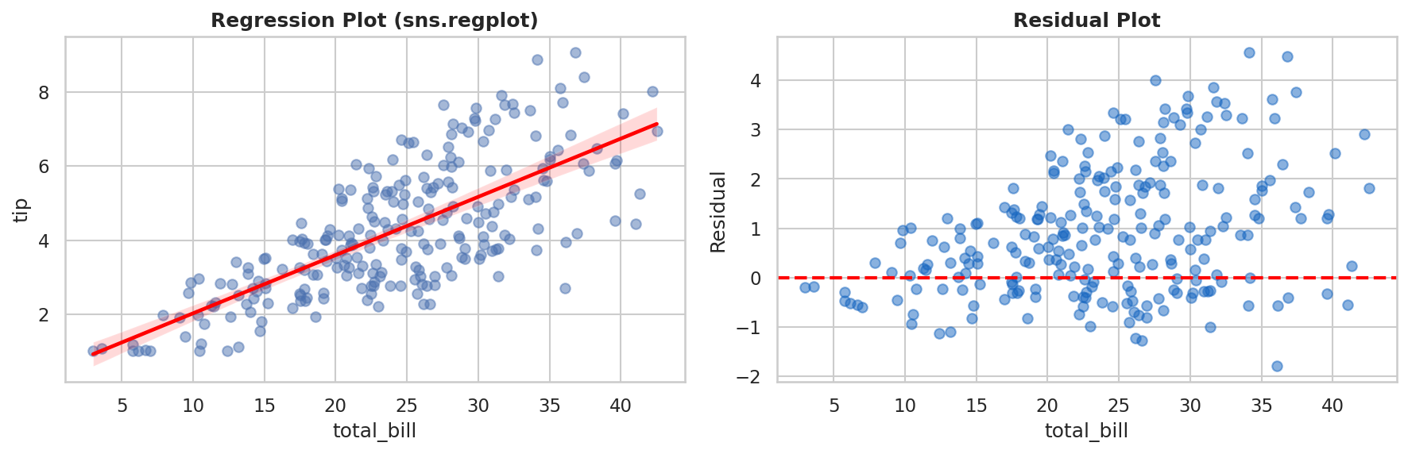

11.1 sns.regplot — Single Regression
regplot — Simple Linear Regression Overlay
import seaborn as sns
tips = sns.load_dataset('tips')

fig, ax = plt.subplots(figsize=(8, 6))
sns.regplot(x='total_bill', y='tip', data=tips,
scatter_kws={'alpha': 0.5, 'color': '#1976D2'},
line_kws={'color': 'red', 'linewidth': 2},
ci=95, # show 95% confidence interval band
ax=ax)
ax.set_title('Total Bill vs Tip (with regression)', fontweight='bold')
plt.tight_layout(); plt.show()

11.2 sns.lmplot — Faceted Regression
lmplot is the figure-level version of regplot. It can split the regression by a categorical variable using hue, col, or row — you get separate regression lines per group.
lmplot — Separate Lines Per Group
# Separate regression line per day
sns.lmplot(x='total_bill', y='tip', data=tips,
hue='day', # different color + line per day
palette='deep',
markers='o',
scatter_kws={'s': 50},
ci=95,
aspect=1.4)

# Separate plots per time
sns.lmplot(x='total_bill', y='tip', data=tips,
col='time', # separate column per time (Lunch/Dinner)
hue='sex')

11.3 Residual Plot
A residual plot shows the errors (actual − predicted) on the Y axis vs the fitted values (or X) on the X axis. A well-behaved model should show randomly scattered residuals around zero with no pattern. Any visible pattern means the model is missing something.
Residual Plot
# Using seaborn
sns.residplot(x='total_bill', y='tip', data=tips, lowess=True,
scatter_kws={'alpha': 0.5},
line_kws={'color': 'red', 'linewidth': 2})
ax.axhline(0, color='black', linewidth=1)

# Manually
from sklearn.linear_model import LinearRegression
import numpy as np

X = tips[['total_bill']]
y = tips['tip']
model = LinearRegression().fit(X, y)
residuals = y - model.predict(X)

plt.scatter(model.predict(X), residuals, alpha=0.6)
plt.axhline(0, color='red', linestyle='--')

11.4 DS / ML Use Cases
OLS Regression Analysis: Check if linear regression assumptions hold — scatter should be random around zero in residual plot.
Feature Engineering: If regplot shows a curve (not line), try log-transforming the feature.
Predicted vs Actual Plot: For any regression model, scatter plot of predicted vs actual values — perfect model = all points on diagonal.
⚠ If residuals show a fan-shaped pattern (increasing variance), you have heteroscedasticity — try log-transforming the target variable.

12. Pie Chart & Donut Chart
Pie charts show parts of a whole — each slice represents a percentage of the total. Donut charts are just pie charts with the center cut out, which makes them easier to read (the center can also hold a summary number).
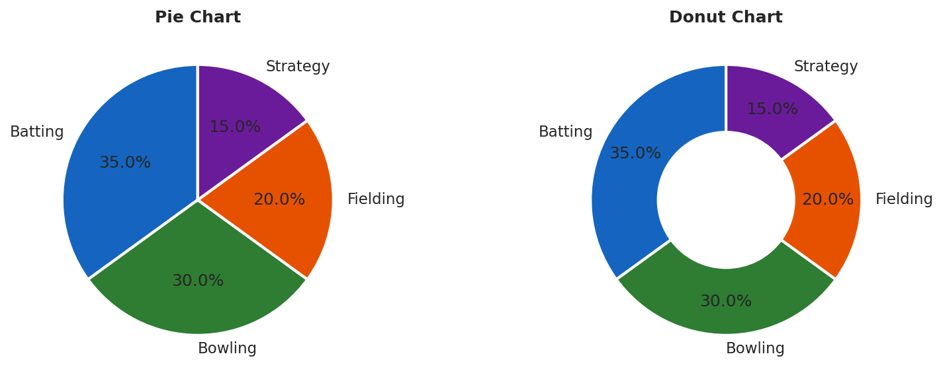

12.1 When to Use (and NOT Use) Pie Charts
Use Pie Chart | Avoid Pie Chart
3-5 categories at most | More than 5-6 slices (too hard to compare)
Proportions are very different (e.g., 70% vs 30%) | When differences are subtle (e.g., 24% vs 26%)
Showing part-to-whole is the main point | When you need to compare exact values across groups
Non-technical audience | Scientific/analytical reports (use bar chart instead)

12.2 Python Code
Pie and Donut Charts
import matplotlib.pyplot as plt

labels = ['Revenue', 'COGS', 'Marketing', 'R&D']
sizes = [45, 30, 15, 10]
colors = ['#1565C0', '#2E7D32', '#E65100', '#6A1B9A']
explode = [0.05, 0, 0, 0] # "explode" the first slice slightly

# Pie Chart
fig, axes = plt.subplots(1, 2, figsize=(12, 5))
axes[0].pie(sizes, labels=labels, colors=colors,
autopct='%1.1f%%', # show % on each slice
startangle=90, # start from top
explode=explode,
wedgeprops=dict(edgecolor='white', linewidth=2))
axes[0].set_title('Budget Breakdown', fontweight='bold')

# Donut Chart (just add width parameter)
axes[1].pie(sizes, labels=labels, colors=colors,
autopct='%1.1f%%', startangle=90, pctdistance=0.75,
wedgeprops=dict(width=0.5, edgecolor='white', linewidth=2))
axes[1].text(0, 0, '100%', ha='center', va='center',
fontsize=18, fontweight='bold') # center text
axes[1].set_title('Budget Donut', fontweight='bold')
plt.tight_layout(); plt.show()

12.3 Edge Cases & Pitfalls
⚠ Pie charts are among the most misused chart types. When in doubt, use a horizontal bar chart — it allows easier comparisons and handles more categories.
Problem | Fix
Slices don't add to 100% | Double-check data; normalize if needed
Percentages show wrong values | Verify data isn't already percentages (would double-count)
3D pie chart requested | Always reject — 3D distorts slice areas. Use flat 2D only.
Too many thin slices | Group small categories into "Other"

13. Area Chart
An area chart is a line chart where the area below the line is filled with color. A stacked area chart shows multiple series stacked on top of each other, useful for showing how the composition of a total changes over time.
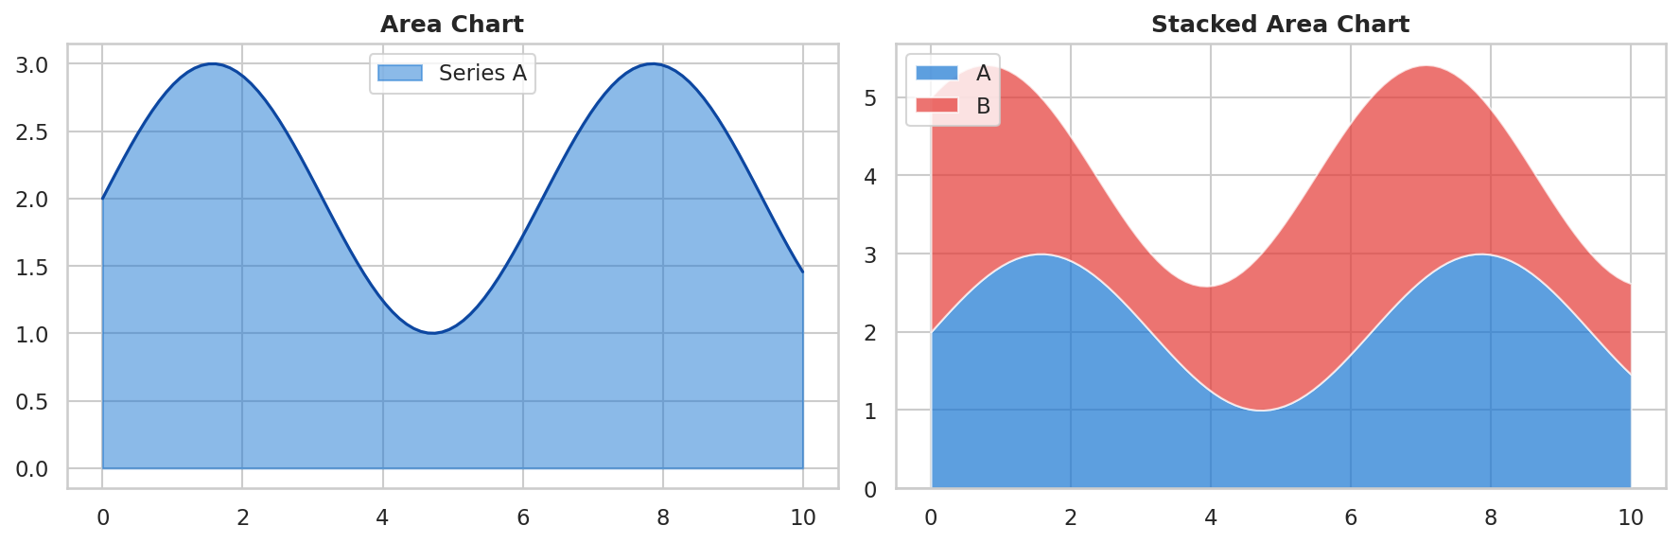

13.1 Python Code
Area and Stacked Area Charts
import matplotlib.pyplot as plt
import numpy as np

x = np.linspace(0, 10, 100)
y1 = np.sin(x) + 2
y2 = np.cos(x) + 3

fig, axes = plt.subplots(1, 2, figsize=(13, 5))

# Simple area chart
axes[0].fill_between(x, y1, alpha=0.5, color='#1976D2', label='Series A')
axes[0].plot(x, y1, color='#0D47A1', linewidth=1.5) # line on top
axes[0].set_title('Area Chart', fontweight='bold'); axes[0].legend()

# Stacked area chart
axes[1].stackplot(x, [y1, y2], labels=['A', 'B'],
colors=['#1976D2', '#E53935'], alpha=0.7)
axes[1].legend(loc='upper left')
axes[1].set_title('Stacked Area Chart', fontweight='bold')

plt.tight_layout(); plt.show()

13.2 DS / ML Use Cases
Time-series decomposition: Stacked area chart showing trend + seasonality + residual components.
Resource utilization: CPU / GPU / memory usage over training time — each stacked layer is one component.
Category proportions over time: How market share changed across competitors year by year.

14. Hexbin Plot
A hexbin plot divides the plotting area into hexagonal bins and counts how many data points fall into each hexagon. The darker (or brighter) the hexagon, the more points it contains. It is the solution to overplotting — when you have so many points in a scatter plot that they cover each other.
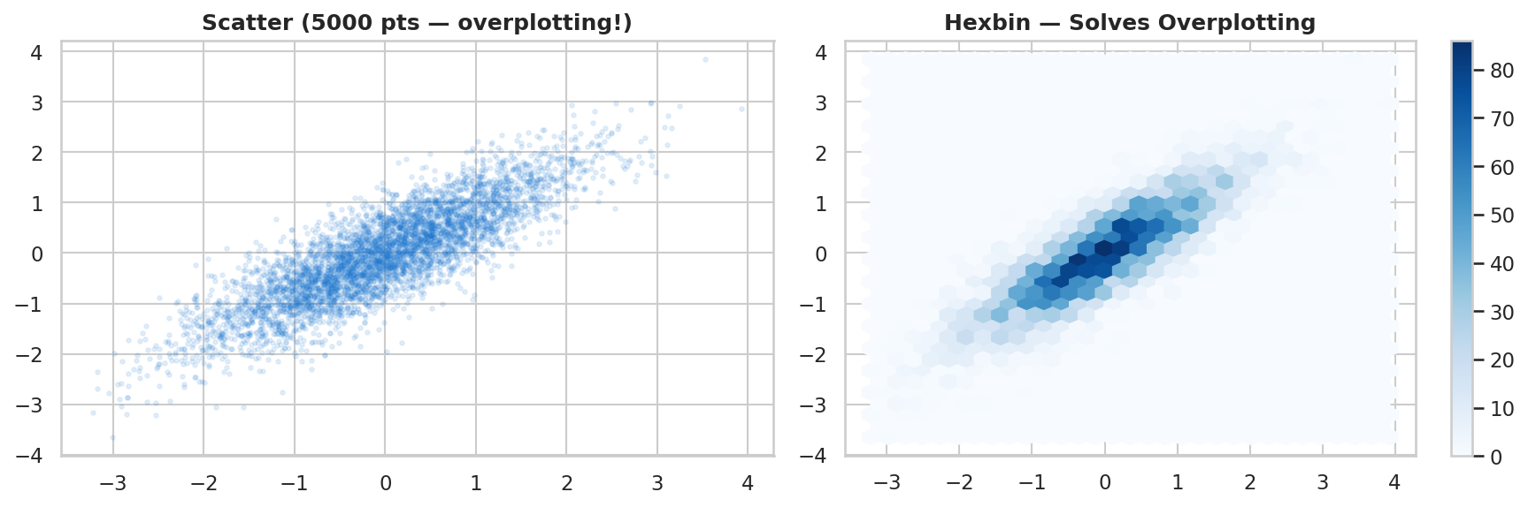

14.1 Python Code
Hexbin Plot
import matplotlib.pyplot as plt
import numpy as np

np.random.seed(42)
x = np.random.randn(10000)
y = x * 0.8 + np.random.randn(10000) * 0.5

fig, ax = plt.subplots(figsize=(8, 6))
hb = ax.hexbin(x, y,
gridsize=40, # number of hexagons per axis
cmap='Blues', # colormap
mincnt=1) # hide empty hexagons

plt.colorbar(hb, ax=ax, label='Count')
ax.set_title('Hexbin — 10,000 Points', fontweight='bold')
plt.tight_layout(); plt.show()

14.2 DS / ML Use Cases
Large dataset EDA: When working with millions of rows, scatter plots are unreadable. Hexbin shows the density structure clearly.
Predicted vs Actual: For large regression datasets, hexbin shows where the model is most accurate (dark hexagons on the diagonal).
✅ Use hexbin whenever your scatter plot has > 5,000–10,000 points and you can't see the distribution clearly.

15. ROC Curve & AUC
The ROC (Receiver Operating Characteristic) curve plots True Positive Rate (Recall) on the Y-axis against False Positive Rate on the X-axis at every possible classification threshold. It summarizes the performance of a binary classifier across all thresholds.
The AUC (Area Under the Curve) is a single number — the area under the ROC curve. AUC = 1.0 means perfect classifier. AUC = 0.5 means random (diagonal line). AUC = 0.0 means perfectly wrong.
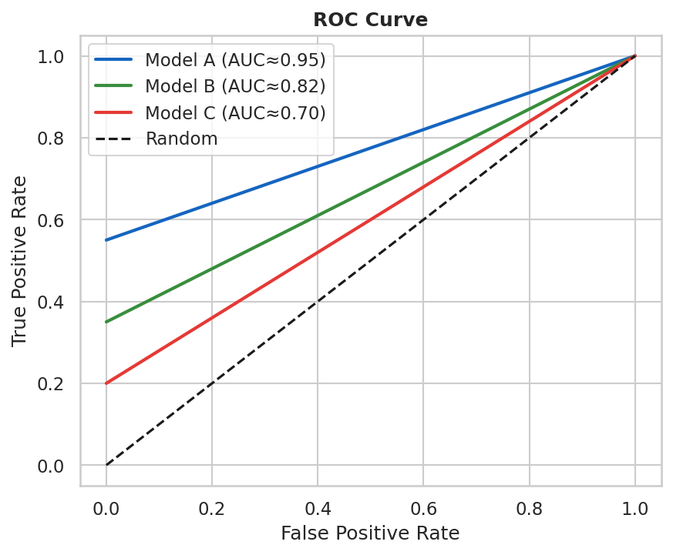

15.1 Python Code
ROC Curve with sklearn
from sklearn.metrics import roc_curve, auc
from sklearn.linear_model import LogisticRegression
import matplotlib.pyplot as plt

# Train a model
model = LogisticRegression()
model.fit(X_train, y_train)
y_proba = model.predict_proba(X_test)[:, 1]

# Calculate ROC
fpr, tpr, thresholds = roc_curve(y_test, y_proba)
roc_auc = auc(fpr, tpr)

fig, ax = plt.subplots(figsize=(7, 6))
ax.plot(fpr, tpr, color='#1565C0', lw=2, label=f'AUC = {roc_auc:.3f}')
ax.plot([0,1],[0,1], 'k--', lw=1.5, label='Random Classifier')
ax.fill_between(fpr, tpr, alpha=0.1, color='#1565C0') # shade AUC
ax.set_xlabel('False Positive Rate (FPR)')
ax.set_ylabel('True Positive Rate (TPR = Recall)')
ax.set_title('ROC Curve', fontweight='bold')
ax.legend(); plt.tight_layout(); plt.show()

✅ When comparing multiple models, plot all ROC curves on the same axes. The model with the highest AUC (and the curve furthest to the upper-left) is the best.

15.2 DS / ML Use Cases
Model selection: Compare ROC curves of different classifiers — Logistic Regression vs SVM vs Random Forest.
Threshold tuning: Choose the threshold that balances FPR/TPR based on your business cost (false positives vs false negatives).
Imbalanced data: Unlike accuracy, AUC is robust to class imbalance.

16. Feature Importance Plot
A feature importance plot shows which input variables (features) had the most influence on a model's predictions. It is almost always shown as a horizontal bar chart sorted by importance score, making it easy to read even with many features.


16.1 Python Code
Feature Importance from Random Forest
from sklearn.ensemble import RandomForestClassifier
import pandas as pd
import matplotlib.pyplot as plt

# Train model
model = RandomForestClassifier(n_estimators=100)
model.fit(X_train, y_train)

# Get importance scores
importances = model.feature_importances_
features = X_train.columns

# Sort and plot
fi = pd.Series(importances, index=features).sort_values()
fig, ax = plt.subplots(figsize=(9, 6))
fi.plot(kind='barh', ax=ax, color='#1565C0')
ax.set_xlabel('Feature Importance Score')
ax.set_title('Random Forest Feature Importance', fontweight='bold')

# Add value labels
for i, v in enumerate(fi):
ax.text(v + 0.002, i, f'{v:.3f}', va='center', fontsize=9)

plt.tight_layout(); plt.show()

16.2 DS / ML / DL Use Cases
Feature selection: Remove features with near-zero importance to reduce overfitting and speed up inference.
Model debugging: If an obviously irrelevant feature has high importance, there may be a data leakage bug.
DL/SHAP: For neural networks, use SHAP values — plot a SHAP summary (beeswarm) instead of simple bar chart for richer insights.

17. t-SNE / UMAP Visualization
t-SNE and UMAP are dimensionality reduction algorithms. They take high-dimensional data (like 512-dimensional image embeddings or 768-dimensional text embeddings) and compress it to 2D so you can visualize it as a scatter plot.
If samples of the same class cluster together in the 2D projection, your model has learned good representations. Overlapping clusters mean poor separation.


17.1 Python Code
t-SNE Visualization
from sklearn.manifold import TSNE
import matplotlib.pyplot as plt
import numpy as np

# Assume X = (N, 512) high-dimensional features, y = class labels
X = np.random.randn(500, 512) # example: 500 samples, 512 features
y = np.random.choice([0,1,2,3], 500)

# Reduce to 2D
tsne = TSNE(n_components=2, random_state=42,
perplexity=30, # typical: 5-50
max_iter=1000)
X_2d = tsne.fit_transform(X)

# Plot
fig, ax = plt.subplots(figsize=(9, 7))
colors = ['#1565C0', '#E53935', '#388E3C', '#F57F17']
for cls in range(4):
mask = (y == cls)
ax.scatter(X_2d[mask, 0], X_2d[mask, 1],
c=colors[cls], label=f'Class {cls}', alpha=0.7, s=30)
ax.legend(title='Class')
ax.set_title('t-SNE — 512D → 2D Projection', fontweight='bold')
plt.tight_layout(); plt.show()

ℹ t-SNE: Run only on a sample (< 10,000 points) as it is slow (O(n²)). UMAP is faster and better preserves global structure.

17.2 DS / ML / DL / CV Use Cases
CV: After training a CNN, extract penultimate layer features and apply t-SNE — well-trained models show clearly separated clusters per class.
NLP: Visualize word embeddings or sentence embeddings — semantically similar words cluster together.
Anomaly detection: Normal data points form a tight cluster; anomalies appear as isolated dots far from the cluster.

18. Plotly — Interactive Plots
Plotly creates interactive charts that you can zoom, pan, hover, and click. Unlike Matplotlib, Plotly outputs HTML — perfect for dashboards, web apps (Dash, Streamlit), and Jupyter notebooks where you want to explore data dynamically.

18.1 Plotly Express — Quick Plots
Plotly Express — One Line Interactive Charts
import plotly.express as px
import seaborn as sns

tips = sns.load_dataset('tips')

# Interactive scatter
fig = px.scatter(tips, x='total_bill', y='tip',
color='day', hover_data=['sex', 'smoker'],
title='Interactive Scatter — hover for details')
fig.show()

# Interactive bar
fig = px.bar(tips.groupby('day')['total_bill'].mean().reset_index(),
x='day', y='total_bill', title='Mean Bill by Day')
fig.show()

# Interactive line
fig = px.line(df, x='date', y='value', color='category',
title='Time Series — Zoomable')
fig.show()

18.2 Cufflinks — Pandas + Plotly
Cufflinks connects Pandas DataFrames directly to Plotly. You can call .iplot() on any DataFrame column exactly like .plot().
Cufflinks One-Liners
import cufflinks as cf
cf.go_offline() # run offline in Jupyter

# Line chart for a single column
tips['total_bill'].iplot(color='blue', title='Total Bills')

# Bar chart from grouped data
tips.groupby('day')['tip'].mean().iplot(kind='bar', title='Mean Tip by Day')

# Scatter plot
tips.iplot(kind='scatter', x='total_bill', y='tip', mode='markers')

# Box plot
tips[['total_bill', 'tip']].iplot(kind='box')

18.3 Plotly Graph Objects — Full Control
Custom Plotly Chart (Graph Objects)
import plotly.graph_objects as go

fig = go.Figure()
fig.add_trace(go.Bar(
x=['A', 'B', 'C', 'D'],
y=[10, 25, 7, 18],
marker_color=['#1565C0','#E53935','#388E3C','#F57F17'],
text=[10, 25, 7, 18],
textposition='outside'
))
fig.update_layout(
title='Custom Interactive Bar Chart',
xaxis_title='Category',
yaxis_title='Value',
template='plotly_white'
)
fig.show()

ℹ Use Plotly when building dashboards (Dash/Streamlit) or when stakeholders need to explore data interactively. For static reports and papers, use Matplotlib/Seaborn.

19. Working with Images in Matplotlib
Matplotlib can load and display images, which is critical in Computer Vision (CV) workflows. Images in NumPy are just 3D arrays: (height, width, channels). Every pixel operation becomes an array operation.

19.1 Loading and Displaying Images
Load, Display, Crop Images
import matplotlib.image as mpimg
import matplotlib.pyplot as plt
import numpy as np

# Load image (returns NumPy array: shape = H × W × 3 for RGB)
img = mpimg.imread('flower.jpg') # or use PIL/OpenCV
print(img.shape) # e.g., (480, 640, 3)
print(img.dtype) # uint8 (values 0-255)

# Display
fig, axes = plt.subplots(1, 3, figsize=(15, 5))
axes[0].imshow(img)
axes[0].axis('off')
axes[0].set_title('Original Image')

# Crop: img[row_start:row_end, col_start:col_end]
cropped = img[50:200, 100:300]
axes[1].imshow(cropped)
axes[1].axis('off')
axes[1].set_title('Cropped')

# Grayscale
gray = np.mean(img, axis=2).astype(np.uint8)
axes[2].imshow(gray, cmap='gray')
axes[2].axis('off')
axes[2].set_title('Grayscale')

plt.tight_layout(); plt.show()

Channel Manipulation
# Separate RGB channels
r, g, b = img[:,:,0], img[:,:,1], img[:,:,2]

# Show only red channel
fig, axes = plt.subplots(1, 4, figsize=(16, 4))
for ax, channel, title, cmap in zip(axes,
[img, r, g, b], ['RGB','Red','Green','Blue'],
[None,'Reds','Greens','Blues']):
ax.imshow(channel, cmap=cmap); ax.axis('off'); ax.set_title(title)

19.2 CV Use Cases
Model debugging: Display images alongside model predictions. Show side-by-side: original, ground truth mask, predicted mask.
Data augmentation preview: Before training, visualize augmented samples to ensure augmentation is correct.
Activation map visualization: Show which areas of an image a CNN focuses on (Grad-CAM heatmaps).
Batch visualization: Display a 4×4 or 8×8 grid of training samples to inspect dataset quality.
Image Grid (Batch Visualization)
def show_image_grid(images, labels, n=16):
"""Show n images in a grid with their labels."""
fig, axes = plt.subplots(4, 4, figsize=(12, 12))
for i, ax in enumerate(axes.flat):
if i < n:
ax.imshow(images[i])
ax.set_title(f'Label: {labels[i]}', fontsize=8)
ax.axis('off')
plt.suptitle('Training Batch Sample', fontweight='bold')
plt.tight_layout(); plt.show()

20. Axis, Titles & Professional Styling
Great data always gets overlooked when the chart looks amateur. Professional styling is not about making things pretty — it's about making your data readable, trustworthy, and publication-ready.

20.1 Complete Styling Template
Professional Plot Template
import matplotlib.pyplot as plt
import seaborn as sns

# ── 1. Set global style ─────────────────────────────────────────────────
plt.rcParams.update({
'font.family': 'Arial',
'font.size': 11,
'axes.titlesize': 14,
'axes.titleweight': 'bold',
'axes.labelsize': 12,
'xtick.labelsize': 10,
'ytick.labelsize': 10,
'legend.fontsize': 10,
'figure.dpi': 150,
'axes.spines.top': False, # remove top border
'axes.spines.right': False, # remove right border
'axes.grid': True,
'grid.alpha': 0.35,
'grid.linestyle': '--',
})

# ── 2. Create figure ────────────────────────────────────────────────────
fig, ax = plt.subplots(figsize=(10, 6))

# ── 3. Your plot ────────────────────────────────────────────────────────
# ax.plot(...) or ax.bar(...) etc.

# ── 4. Title, axis labels ───────────────────────────────────────────────
ax.set_title('Main Title Here', fontsize=15, fontweight='bold', pad=15)
ax.set_xlabel('X Variable (units)', fontsize=12, labelpad=10)
ax.set_ylabel('Y Variable (units)', fontsize=12, labelpad=10)

# ── 5. Legend ───────────────────────────────────────────────────────────
legend = ax.legend(title='Group Variable', loc='upper left',
framealpha=0.9, edgecolor='#BFCDD8')
legend.get_title().set_fontweight('bold')

# ── 6. Grid behind data ─────────────────────────────────────────────────
ax.set_axisbelow(True)

# ── 7. Data source annotation ───────────────────────────────────────────
fig.text(0.01, -0.02, 'Source: Dataset Name | Author: Your Name',
ha='left', fontsize=8, color='gray')

# ── 8. Save ─────────────────────────────────────────────────────────────
plt.tight_layout()
plt.savefig('plot.png', dpi=300, bbox_inches='tight') # high-res
plt.show()

20.2 Colors & Colormaps
Color Purpose | Recommended Choice | Example Code
Single series | Named color or hex | color='#1565C0'
Categorical groups | qualitative palette | palette='Set2' or 'tab10'
Sequential data (count, density) | Blues, YlOrRd, viridis | cmap='Blues'
Diverging data (correlation, change) | coolwarm, RdBu, PiYG | cmap='coolwarm'
Colorblind-safe | colorblind palette | sns.set_palette('colorblind')

20.3 Saving Plots
Saving Plots in Different Formats
# High-resolution for publication/print
plt.savefig('figure.png', dpi=300, bbox_inches='tight', facecolor='white')

# PDF for vector graphics (best for papers/reports)
plt.savefig('figure.pdf', bbox_inches='tight')

# SVG for web / editing in Illustrator
plt.savefig('figure.svg', bbox_inches='tight')

# Transparent background
plt.savefig('figure.png', dpi=300, transparent=True, bbox_inches='tight')

21. Quick Reference — Choose the Right Plot
Use this table as a cheat sheet. Find your question/data type in the first column, then pick the chart.
Your Data / Question | Best Chart | Alternative
Compare values across categories | Bar Chart (vertical) | Dot plot, Lollipop chart
Compare distributions across groups | Box Plot | Violin Plot, Strip Plot
Show distribution of ONE numeric var | Histogram + KDE | ECDF, Violin Plot
Show relationship: two numeric vars | Scatter Plot | Hexbin (large data)
Show trend over time | Line Chart | Area Chart
Show part-to-whole (≤ 5 categories) | Pie / Donut Chart | Stacked Bar Chart
Show part-to-whole OVER TIME | Stacked Area Chart | 100% Stacked Bar
Correlation matrix / grid data | Heatmap | Pair Plot
Classify model evaluation | Confusion Matrix Heatmap | ROC Curve
Regression model performance | Scatter: Predicted vs Actual | Residual Plot
Feature importance | Horizontal Bar Chart (sorted) | SHAP beeswarm
High-dimensional data in 2D | t-SNE / UMAP Scatter | PCA Biplot
All pairwise relationships | Pair Plot (sns.pairplot) | Correlation Heatmap
Count per category | Count Plot / Bar Chart | Treemap
Large scatter (> 5000 pts) | Hexbin Plot | Contour / density plot
Binary classifier performance | ROC Curve + AUC | Precision-Recall Curve
Group proportions | Grouped Bar or 100% Stacked Bar | Small multiples
Many categories (> 15) | Horizontal Bar (sorted, top-N) | Treemap
Ranked comparison | Horizontal Bar (sorted) | Lollipop chart
Interactive exploration | Plotly (any chart type) | Bokeh, Altair

Golden Rules of Data Visualization
✅ 1. TITLE: Every chart must have a specific, descriptive title. Never leave it blank.
✅ 2. AXES: Always label both axes with the variable name AND units.
⚠ 3. START AT ZERO: Bar charts MUST start at zero. Starting higher is a visual lie.
✅ 4. COLOR: Use colorblind-safe palettes. Avoid rainbow colormaps for continuous data.
✅ 5. LEGEND: Only add a legend when there are multiple groups/series.
⚠ 6. CLUTTER: Remove chart junk — 3D effects, excessive borders, gradients. Less is more.
ℹ 7. AUDIENCE: Simplify for non-technical audiences; add detail for analysts.
✅ 8. RIGHT CHART: Match the chart type to your data type and the question being answered.

